Exercise 8

- How many unique salary packages does our company, Bignet, offer? List them in descending order.
10 unique salary packages
SELECT COUNT(DISTINCT salary) AS unique_salary_packages FROM employee_data;
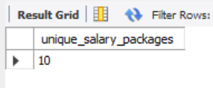
SELECT DISTINCT salary FROM employee_data ORDER BY salary DESC;
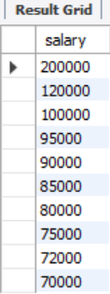
- How many distinct first names do we have in our database?
There are 21 distinct first names
SELECT COUNT(DISTINCT f_name) AS distinct_first_names FROM employee_data;
